# Weekly Report

**Work done in last week ( Attach supporting Documents):**

1. Research on Opencv Library(Python).

**pip install opencv-python(Command to install)**

* OpenCV is a huge open-source library for computer vision, machine learning, and image processing. OpenCV supports a wide variety of programming languages like Python, C++, Java, etc.
* It can process images and videos to identify objects, faces, or even the handwriting of a human. When it is integrated with various libraries, such as Numpy which is a highly optimized library for numerical operations, whatever operations one can do in Numpy can be combined with OpenCV.
* This OpenCV tutorial will help you learn the Image-processing from Basics to Advance, like operations on Images, Videos using a huge set of Opencv-programs and projects.

**Related to PROJECT :-**

**Object Detection via image processing**

* Object detection is a computer technology related to computer vision and image processing that deals with detecting instances of semantic objects of a certain class

(such as humans, buildings, or cars) in digital images and videos.

* So we have used opencv library for object detection in our project (smart cctv), (Detect ->Process -> store) it means that first it would detect the user then it will process the image after image processing is done after that it will store in form of image/video after tracking in camera .So in this flow our project will work .

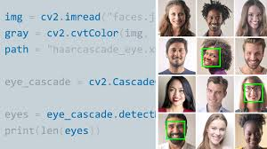

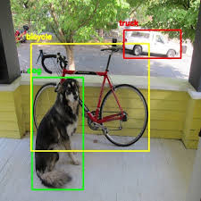

**Reason for incomplete work:**

* Research on python libraries and frameworks needed for the project development.

**Plans for next week:**

1. Pillow.

2. Tkinter Python.

## References:

* https://pypi.org/project/opencv-python/
* https://www.geeksforgeeks.org/opencv-python-tutorial/

## Signature of External Guide Signature of Internal Guide